# FACCTS – questions

## General

Is there any user role-dependent functionality? Could you explain please the role set and the functionality allowed for each role?

Is there any documentation approximately describing the data structure of the application?

There are some interfaces on mock ups for case input (eCourt, Sustain, Banner). Is there any additional use cases/documentation/functionality/etc. for that ones?

## Case Status

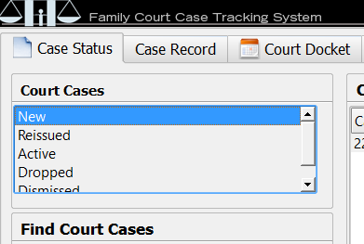

Do you want to choose the single item or multiple ones?

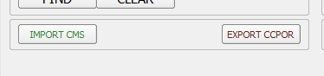

Which workflow is there for “Import CMS” and “Export CCPOR” buttons?

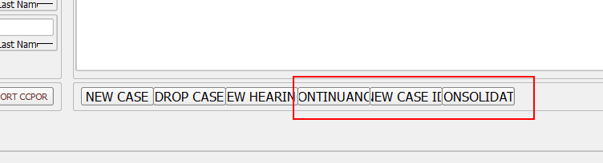

Which workflow/what the program should do if the user press buttons “Continuance”, “New case ID”, “Consolidate”?

## Case record

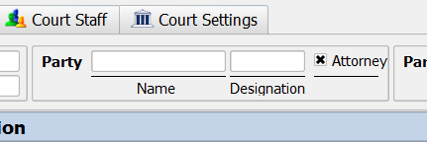

Do you have any rules related to the control “party” above? For example, if the user press “Attorney” does it mean that “Name” and “Designation” fields leave unfilled?

Are there any rules for “Designation” field?

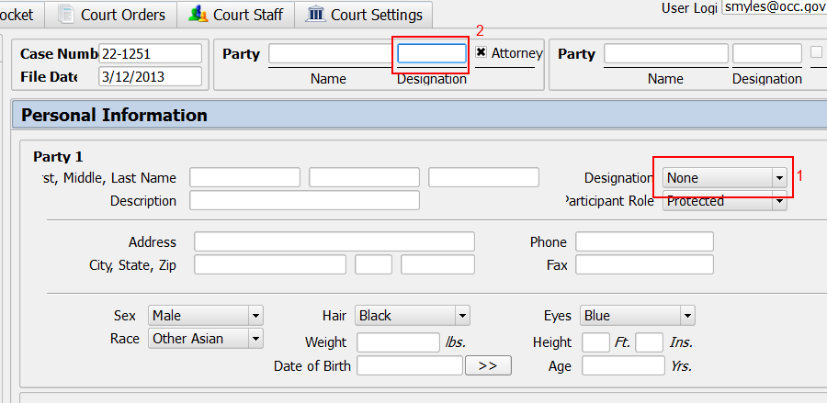

If the field called Designation (1) changed should that change be displayed in the similar field (2) ?

Are there any validation rules for “Phone”, “Fax” or some else text fields?

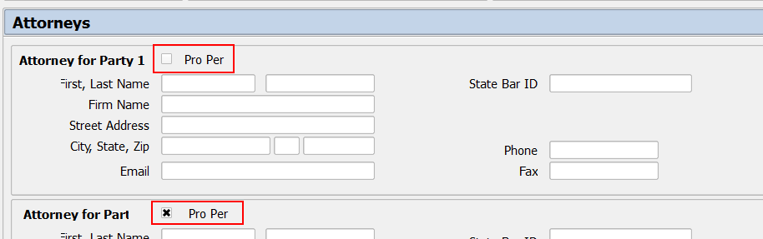

What does mean “Pro Per” checkbox?

Are there any rules for the “Checked/Unchecked” state for that option?

## Court Docket

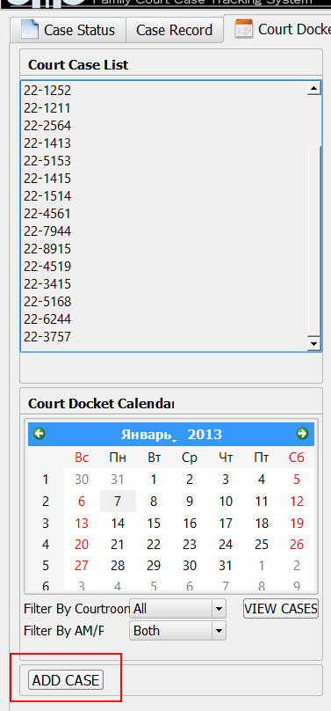

Which workflow is there for adding the case here?

## Court Orders

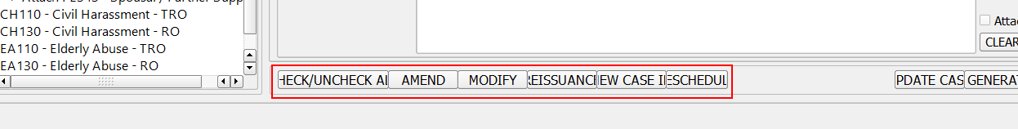

Which workflow is there for “Check/Uncheck all”, “Amend”, “Modify”, “Reissuance”, “New Case ID”, “Reschedule”?

## Case Update

“New Court Date” – “Reissuance” – “Related cases” – “Consolidate” – “New Case Number” – which workflow (DB data-dependent) is there for any functionality?

Which data set is the minimal one that allowed the user to proceed (press “OK”/”Update” button etc.) for that functionalities?

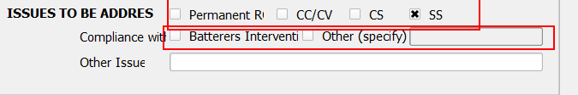

Are the selected in red options are single-selectable or multi-selectable?

## Court Settings

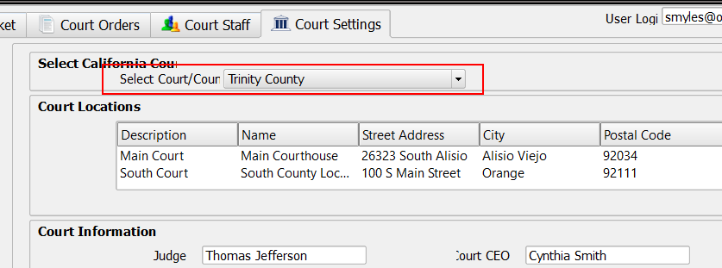

When the user changed the combo box on top what data of other parts of the application would be affected?